CHEMMAT 203 – Transfer Processes 1
Assignment 2 (5%): Fluid Dynamics Assignment Due: 1 November 2020

Introduction
In a chemical processing plant, methyl alcohol fluid ($ρ=790\frac{kg}{m^{3}}$, $μ=5.6 ×{10}^{-4} Pa.s$) is to be transferred from reservoir 1 to reservoir 2 by flowing through pipes connecting the two tanks and by passing through a pump, delivering a head of $h_{pump}=80$ m to the fluid. As can be seen in Fig.1, reservoir 2 is located $55$ m above the reservoir 1. Both reservoirs are assumed large and open to atmosphere. Overall length of the connecting pipe is $L= 85 m$, and the pipe diameter is $d =250 mm$. All loss coefficients ($K_{L}$ ) involved in the fluid flow are illustrated in Fig.1.
Based on what you have learned in the fluid mechanics component of this course, you are supposed to analyse the fluid flow in the pipe, taking into account major and minor energy losses.
In order to fulfil the tasks described in following section, develop a MATLAB programme. The MATLAB programme that you will develop in this assignment, would help you to find Darcy friction factor for a given Reynolds number and relative roughness, without having to refer to Moody Chart, and it works for both laminar and turbulent flows.

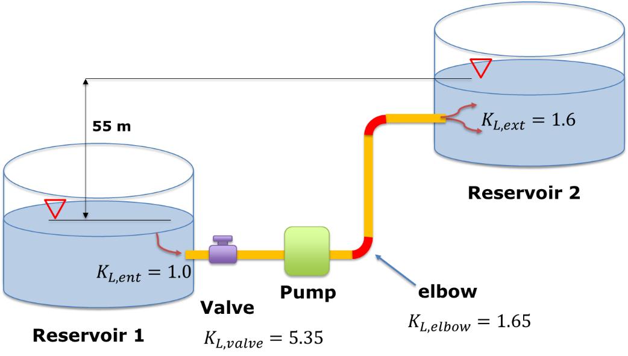

Figure 1. Fluid to flow from reservoir 1 to reservoir 2
Problem statement

- Volumetric flowrate of fluid in the pipe and pump power

Using given information above and by MATLAB programming, determine the volumetric flowrate of fluid in the pipe and the pump power. You are welcome to write the code, using your own approach and it must meet the following requirements:

- The code should find Darcy friction factor, $f$ for both laminar, and turbulent flow regimes based on the Reynolds number.
- If the relative roughness, $ε/d$ is greater that 0.05 (over the range of Moody chart), or 2000$≤$Re$≤$4000 (transition regime) the code should give a proper warning message(s) in each circumstance (or both).
Below is a suggested approach to help you, but you can use your own method to develop your code.

Suggested step-by-step guide
In a MATLAB script:
- Assume a value for Darcy friction factor, $f$ as a first guess. ($f_guess$)
- Simplify the energy equation using the Extended Bernoulli Equation.
- Determine fluid velocity in the pipe, $v$ [m/s] using $f_guess$.
- Based on $v$, determine Reynolds number, $Re$.
- Based on the Reynolds number, your code must solve for $f$ for both laminar (Re < 2000, using Eq. (2)), and turbulent flows (Re > 4000, using Eq. (4)).
- For a turbulent flow use the Supplementary Information on page 4 and 5 to solve the nonlinear equation (EQ. 4) in order to find actual $f$ according to $Re$ and $ε/d$. ($ε:$surface roughness of the pipe). Input: $ε=0.025 mm$. If you use MATLAB`s built-in tools to solve the nonlinear equation, you might want to define an initial value, fi, (EQ.5).
Note: Having done this step, you do not need to find $f$from the Moody chart!
- If ε/d is greater that 0.05 (“over the range of Moody chart”), or 2000$≤$Re$≤$4000 (“transition regime”) the code should give a corresponding warning message (with a text in quotation marks above).
- Compare $f$ with $f_guess$ and if their difference is greater than 0.0001, update $f_guess$ value with $f$ and repeat the steps from step 3.
- Iterate until the difference between f and $f_guess$ is less than 0.0001.
- Once $f$ is finalised, find out $v$ and from there find the flowrate, Q [$m^{3}/s$ ].
- The power of pump [kW] can be found using: $P= ρgQh_{pump}/1000.$

- Parametric Study
Using the MATLAB programme, change the following parameters to fulfil the tasks in below:
B-1: By either manually changing roughness parameter in the code and recording Q and P, or through coding, determine pump power and flow rate if the pipe is made from a material as in the following table:
Table 1. Surface roughness of different pipe materials
Pipe material | Roughness [mm]
Concrete | 2
Copper | 0.61
Cast iron | 0.26
Steel | 0.061
PVC | 0.0015

Store Q and P values corresponding to each roughness in two separate vectors in the code, then using plotyy command, plot the “pump power” and “flow rate” vs “surface roughness” in one 3-axis graph. Label all axes properly (See Fig.2)
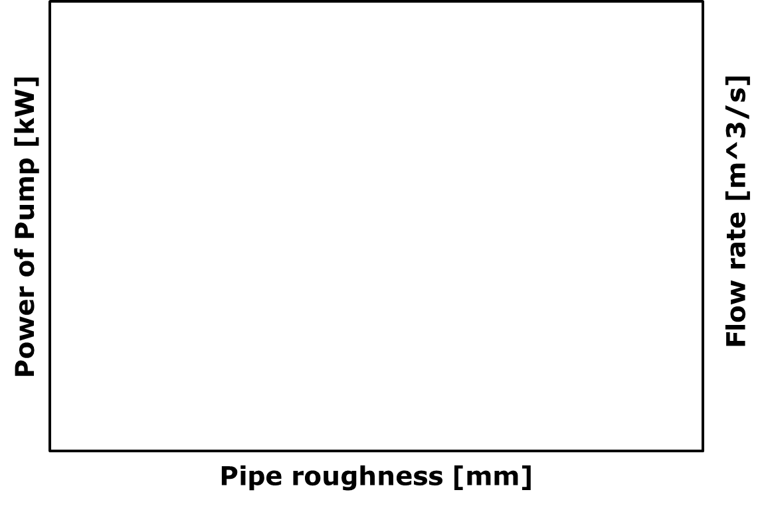
Figure 2. Template of three-axis plot for task B-1
B-2: If the existing steel pipe is to be replaced by a PVC pipe, determine the diameter for the pipe such that a similar flow rate (as the steel pipe) is obtained. A maximum 0.0003 [$m^{3}/s$ ] difference in flow rate is acceptable. Write down your answer in the form of a comment in your script. (%B-2: …).
Note: similar to B-1, you can choose to manually change parameters until you find the answer or through coding.

Report:
No report is required for Assignment 2. Just submit the MATLAB m-file. To make your code easy to follow, put all explanations, e.g. defining parameters in the form of comments in the m-file.

Assessment Plan
This assignment weights 5% of total marks for the course.
Item | Marks
Develop a MATLAB script to fulfil the following tasks:
Part (A) (80 marks)
- Find velocity in the pipe with a guessed friction factor | 10
- Find Re based on v | 5
- find f for laminar flow (if Re<2000) | 5
- Solve f for turbulent flow (the nonlinear equation) | 35
- Show proper warning messages for transition and over range | 5
- Update v and Re based on f, iteration | 10
- Find flowrate | 5
- Find Pump`s power | 5
Part (B) (15 marks)
- B-1- plotting | 10
- B-2 | 5
Programme formatting (5 marks)
Include easy-to-follow explanations in the code and overall tidiness | 5
Total | 100

Supplementary information
When the fluid flows in a circular pipe, pressure drop ($∆p)$or head loss ($h_{L})$ due to friction is given by the Darcy-Weisbach equation:
$$∆p=f \frac{L}{D}\frac{V^{2}}{2g} (1)$$
Where $f$ is the Darcy friction factor. For fully-developed, and incompressible laminar flow in a round pipe :
$$f= \frac{64}{Re} (2)$$
The friction factor for turbulent flow in smooth and rough pipe is correlated with Colebrook equation:
$\frac{1}{\sqrt{f}}= -2 \log_{10 }\left(\frac{ε/D}{3.7}+\frac{2.51}{Re\sqrt{f}}\right) (3)$
where $ε$ is roughness of the pipe wall, and $Re$ is Reynolds number. Equation (3) cannot be solved analytically for $f$ when $ε$ /D (called relative roughness) and $Re$are given. However, if Equation (3) is rearranged as
$$F\left(f\right)= \frac{1}{\sqrt{f}}+2 \log_{10 }\left(\frac{ε/D}{3.7}+\frac{2.51}{Re\sqrt{f}}\right) (4)$$
a numerical root-finding procedure can be used to find the f that makes $F(f) = 0$ when ε/D and $Re$ are known. To solve Eq. (4) by iteration, an initial guess of $f$for the root finder is required which can be obtained from below formula:
$$f= {\left[1.8\log_{10 }\left(\frac{6.9}{Re}+{\left(\frac{ε/D}{3.7}\right)}^{1.11}\right) \right]}^{-2} (5)$$

